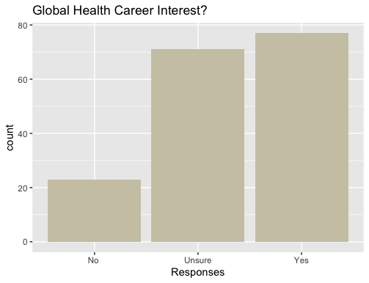

No: 23

Unsure: 71

Yes: 77

1st Year: 30

2nd Year: 72

3rd Year: 45

4th Year: 21

5th Year: 3



18-20: 148

21-23: 19

24-26: 4



No: 150

Yes: 21



No: 143

Yes: 28



|  |  |  |
| --- | --- | --- |
| 1st year | No | 4 |
| 1st year | Unsure | 14 |
| 1st year | Yes | 12 |
| 2nd year | No | 10 |
| 2nd year | Unsure | 29 |
| 2nd year | Yes | 33 |
| 3rd year | No | 6 |
| 3rd year | Unsure | 18 |
| 3rd year | Yes | 21 |
| 4th year | No | 3 |
| 4th year | Unsure | 8 |
| 4th year | Yes | 10 |
| 5th year | Unsure | 2 |
| 5th year | Yes | 1 |



|  |  |  |
| --- | --- | --- |
| 18-20 | No | 21 |
| 18-20 | Unsure | 60 |
| 18-20 | Yes | 67 |
| 21-23 | No | 2 |
| 21-23 | Unsure | 9 |
| 21-23 | Yes | 8 |
| 24-26 | Unsure | 2 |
| 24-26 | Yes | 2 |



|  |  |  |
| --- | --- | --- |
| No | No | 23 |
| No | Unsure | 65 |
| No | Yes | 62 |
| Yes | Unsure | 6 |
| Yes | Yes | 15 |



|  |  |  |
| --- | --- | --- |
| No | No | 22 |
| No | Unsure | 64 |
| No | Yes | 57 |
| Yes | No | 1 |
| Yes | Unsure | 7 |
| Yes | Yes | 20 |

Regression: How well is Interest in Global Health predicted by Age Range, Education, born outside the US, and living outside the US.

Using a simple linear regression; the results are pretty bleak. I think we would need to do a logistic regression. I could figure out how to do that, but it would take some time and I would need to ask some people. Here are the results for the linear regression.

|  |  |  |  |  |
| --- | --- | --- | --- | --- |
| Variable | Estimate | Std Error | T value | P value |
| Q2 (Education) | 0.006623 | 0.066385 | 0.100 | 0.921 |
| Q3 (Age) | -0.007430 | 0.152584 | -0.049 | 0.961 |
| Q10 (Born) | 0.218140 | 0.224442 | 0.972 | 0.333 |
| Q12 (Live) | 0.297827 | 0.200231 | 1.487 | 0.139 |

Overall F-statistic is 2.583 with P-value of .039

R^2 is .0586

Living outside the US is by far the closest to significant results

I don’t know: 81

No: 67

Yes: 13

T test: Interested in Global Health vs non-interested in global health on opinion of global health opportunities.

We counted “I don’t know” as a half a yes and half a no. We also counted the response of “unsure” in interest in global health as “uninterested.

The Two Sample t-test is significant. It had a p-value of .004335 and 95% Confidence Interval (-.234, -.044). In other words, those interested in global health say there are not enough Global Health opportunities (25.7%) compared with those who are not interested in global health (39.7%)

There were 161 total observations.

We removed observations of “I don’t know.”

The two-sample t test is insignificant. It had a p-value of .152 and a 95% confidence interval (-.301, .048). In other words, there is not a significant difference in opinion of global health opportunities among those who are interested (10.9%) and uninterested (23.5%) in global health. There were only 80 observations.



|  |  |
| --- | --- |
| Strongly Agree | 72 |
| Agree | 65 |
| Undecided | 13 |
| Disagree | 10 |
| Strongly Disagree | 1 |





T test: Interested in Global Health vs non-interested in global health on opinion of importance of requiring pre-meds to take a class.

We also counted 2 as strongly agree, -2 as strongly disagree, and so on. We also counted the response of “unsure” in interest in global health as “uninterested.

The Two Sample t-test is significant. It had a p-value of .0088 and 95% Confidence Interval (-.092, .630). In other words, those interested in global health agree that pre-meds should take a class (1.41) compared with those who are not interested in global health (1.05). With 1 being agree and 2 being strongly agree

There were 161 total observations.

|  |  |
| --- | --- |
| Strongly Agree | 8 |
| Agree | 49 |
| Undecided | 48 |
| Disagree | 44 |
| Strongly Disagree | 4 |





T test: Interested in Global Health vs non-interested in global health on opinion of importance of clinical medicine

We also counted 2 as strongly agree, -2 as strongly disagree, and so on. We also counted the response of “unsure” in interest in global health as “uninterested.

The Two Sample t-test is insignificant. It had a p-value of .3914 and 95% Confidence Interval (-.466, .184). In other words, those interested in global health do not have a significantly different opinion on whether practicing clinical medicine is the most important part of global health. The overall means are .085 for Interested Students and .226 for Uninterested students. with 0 being undecided, 1 being agree, and 2 being strongly agree

There were 133 total observations.